**Case Study 1: Variants in a gene for glycine-tRNA-ligase**

1. Genetic Variants

First, find name of gene of glycine-tRNA-ligase (via UniProt) 🡪 [“GARS”](https://www.ensembl.org/Homo_sapiens/Gene/Summary?g=ENSG00000106105;r=7:30594838-30634033) (ENSG00000106105) 🡪 **284 variants found on EVA!**

1. Using Ensembl to explore genetic variation

Snapshot of the summary from Ensembl together with the variation table, that shows variants found for the human GARS gene, filtered for pathogenic, decreasing “MAF” (=pathogen-associated allele frequencies greater than 0.001)



1. As one can see from the table above, no pathogenic or likely pathogenic variant was associated to an allele frequency above 0.001. (Which on the other hand makes sense, because we know that Charcot-Marie Tooth disease is a rare, hereditary disease). Variants, Protein Structure and Function

Some variants thus associated with a disease 🡪 look for effects of the variants on the protein structure and/or function! Snapshot of UniProt’s feature viewer. The red dots e.g. represent mutations/variants of the protein that are likely to be associated to a disease!



**Case Study 2: Search for a variant**

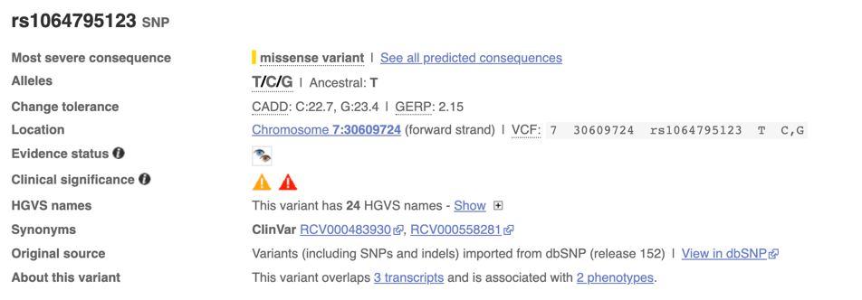For our protein we focused on Variant ID: [rs1064795123](https://www.ensembl.org/Homo_sapiens/Variation/Summary?db=core;g=ENSG00000106105;r=7:30594838-30634033;vf=442963139) (which according to [ClinVar](https://www.ncbi.nlm.nih.gov/clinvar/variation/476764/) is likely to be associated to Charcot-Marie-Tooth disease).

On GWAS however no associations or traits associated with this variant have been found, which is in line with the fact that no MAF entries were found previously…